**Leg of Lamb in a Clementine Crust**   
  
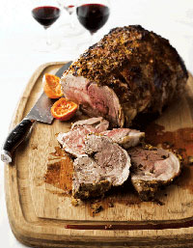SERVES 8 TO 10 MINUTES AS A MAIN COURSE

**Ingredients**

* ½ cup grapefruit juice
* 4 clementines, halved
* 1 cup dry white wine
* 3 garlic cloves
* 2 tablespoons chopped fresh rosemary leaves
* ¼ cup extra virgin olive oil
* 1 boneless leg of lamb (5 to 7 pounds—always get the bigger one), rolled and tied by your butcher
* Salt

**Directions**

1. Combine the grapefruit juice, clementines, wine, garlic, rosemary, 2 tablespoons black pepper, and the oil in a blender or processor, and pulse until the mixture forms a rough paste.

2. Place the lamb in a large, shallow, nonreactive dish or pan. Rub the marinade over it, and turn the lamb to coat it on all sides. Cover, and refrigerate for at least 12 hours (up to 36 hours).

3. Remove the lamb from the marinade, reserving the marinade, and transfer it to a roasting pan. Season the lamb aggressively with salt and pepper, and let it stand at room temperature for 45 minutes. Meanwhile, preheat the oven to 425°F.

4. Rub the reserved marinade over the lamb, and add 1 cup of water to the roasting pan. Place the pan in the oven and roast for 20 minutes.

5. Reduce the oven temperature to 400°F, and continue roasting until an instant-read thermometer registers 130°F for medium-rare, roughly 1 hour and 25 minutes for a large roast. (It may be only 45 minutes for a small one, so be careful and check the temperature after 45 minutes in any case.)

6. Remove the pan from the oven and allow the lamb to rest for 20 minutes before carving.